Activity
Title of activity | What's your emoji?

1. Emoji cards
 | 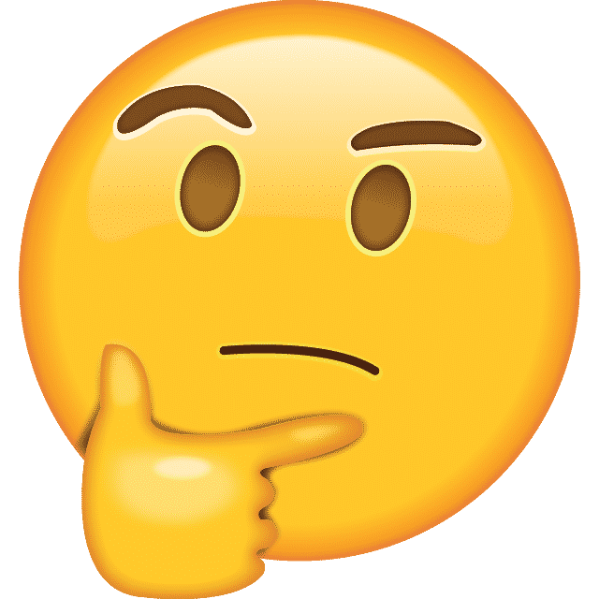
 | 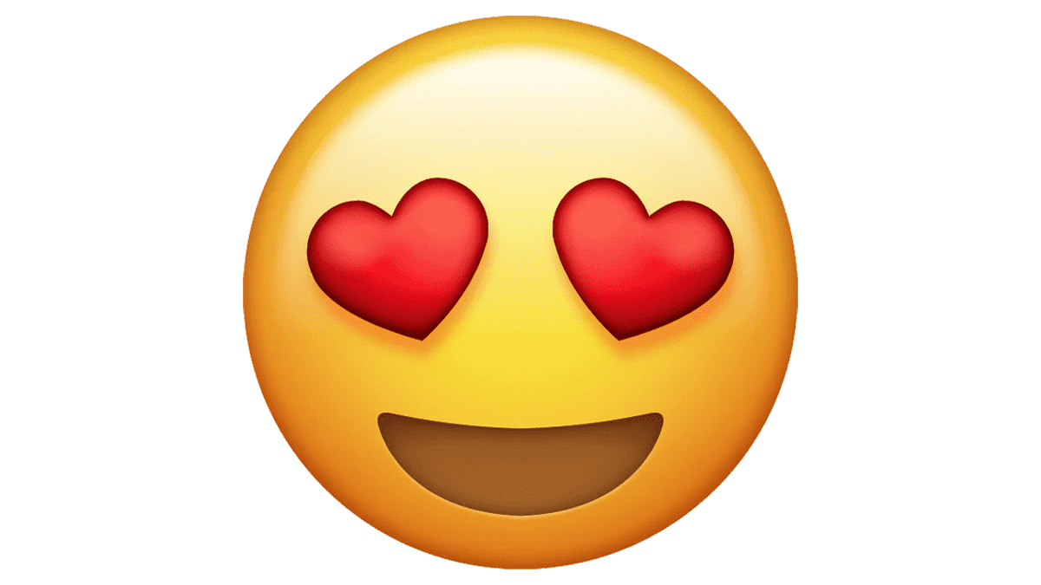
 | 
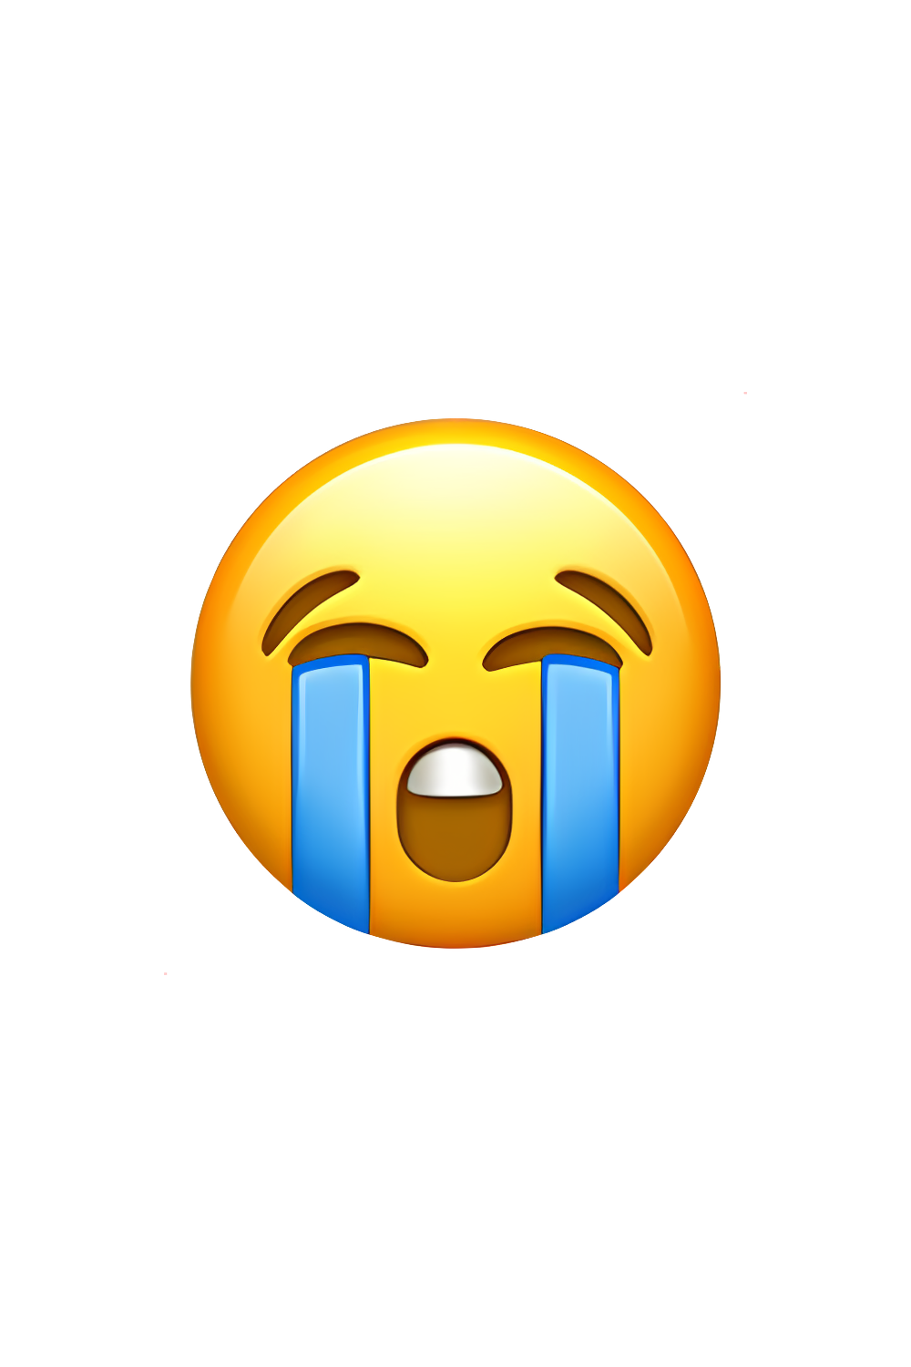 | 
 | 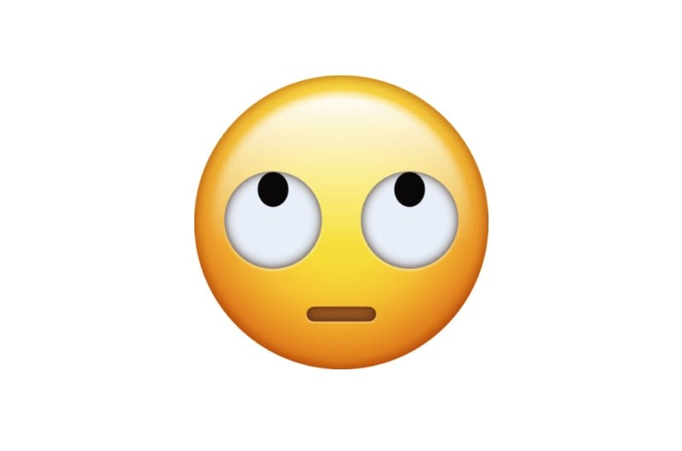

2. Statement cards
You get a follow request on Instagram from someone you do not know in real life.
You see an advertisement on social media saying you will win an iPhone if you share the post on your own social media profile and follow other profiles.
Someone online, who you do not know in real life, has found personal information about you (such as your phone number or your address), and is threatening to make this information public.
You receive a message from an anonymous person harassing you.
You receive an email with a link to sites saying these sites contain more information. You have never heard about these sites before.
You are in an online game that allows you to chat or talk with the other players. The other players are being mean and making hurtful comments about you.
A nude image generated using artificial intelligence is being spread, claiming it is you on the picture.
Someone you do not know in real life is making inappropriate requests in an online conversation you are having.
An influencer you follow is talking about easy ways to make a lot of money quickly.
A friend receives messages from people you know from school or a hobby making mean and hurtful comments.
You have been talking to an online friend, who you don’t know in real life, for a while. They are asking to meet up.
You have seen a very violent video that you actually did not want to see.
A friend plays videogames until late at night and is therefore tired and irritable at school.
Someone is sending around pictures of you to the entire school without you knowing about it or having asked for this.

